TECHNICAL PROJECT REPORT

# Title of Invention / Project: AUTO - IRRIGATION SYSTEM (bluetooth enabled)

# Team Members / Inventors:

|  |  |  |  |  |  |
| --- | --- | --- | --- | --- | --- |
| **S. No.** | **Name** | **Department** | **Designation** | **Mobile** | **E-Mail** |
| 1. | AVINASH CHATTURVEDI | CSE(AI ML-1) | Student | 8210162381 | [avinashchaturvedi886@gmail.com](mailto:avinashchaturvedi886@gmail.com) |
| 2. | DEBASHIS GARAI | CSE(AI ML-1) | Student | 7059581577 | [debashis1805@gmail.com](mailto:debashis1805@gmail.com) |
| 3. | ARGHYADIP GHOSH | CSE(AI ML-1) | Student | 7686860501 | [arghyadip.ghosh99@gmail.com](mailto:arghyadip.ghosh99@gmail.com) |
| 4. | SUPRIYA NAIYA | CSE(AI ML-1) | Student | 9038824685 | [Educationhub5274@gmail.com](mailto:Educationhub5274@gmail.com) |
| 5. | Khushal Thakur | ECE | Mentor | 9646030764 | [khushal.thakur@cumail.in](mailto:khushal.thakur@cumail.in) |
| 6. | Anshul Sharma | ECE | Mentor | 9478697475 | [anshulsharma.ece@cumail.in](mailto:anshulsharma.ece@cumail.in) |
| 7. | Kiran Jot Singh | ECE | Mentor | 9463909689 | [kiranjotsingh.ece@cumal.in](mailto:kiranjotsingh.ece@cumal.in) |
| 8. | Divneet Singh Kapoor | ECE | Mentor | 9878422653 | [divneet.ece@cumail.in](mailto:divneet.ece@cumail.in) |

***Section – 1 (IPR Related)***

# Brief Abstract :

* It is for those hardworking farmers. During the season for the irrigation time when the farmers have to travel to their whole field to irrigate their fields which is very difficult to irrigate. In order to avoid the problem we have introduced a new innovation which states that there is a sensor attached which is once dipped into the soil sample will detect the amount of moisture present in the defined soil sample. There is one fixed moisture amount called the threshold moisture value which work in the principle that when the moisture sensor detects the moisture from the soil which if below the threshold moisture value , the Arduino will supply v to the relay motor attached to it which in turn will turn on the motor which will provide water to the given oil sample till the moisture value detected by the moisture sensor become above the threshold value detected by the moisture sensor from the soil.
* Our innovative system can also be used in gardens while watering the plants in the gardens.
* The additional modification that we are including in our product is that we have the plan that the data that the moisture sensor is detecting will be displayed in the web server .Actually our basic idea is that we want the entire data to be available to the Punjab government so that the government has an entire record of any wastage of water in any of the agricultural field in Punjab.
* Basically the process that is used till date is very hardworking and also very back dated, as it is the era of science so for making things easier regarding the irrigation system our idea can be an helpful idea to the government and also to the society.
* It is nothing but a smarter way to irrigate the field not only that it is also less expensive which makes the product to be easily affordable to the farmers.

# Existing state-of-the-art and Drawbacks in existing state-of-the-art

|  |  |  |
| --- | --- | --- |
| **S. No.** | **Existing state of art** | **Drawbacks in existing state of art** |
| 1. | WATERING PLANTS IN GARDEN | GARDENERS HAVE TO MANUALLY WATER THE PLANTS IN THE GARDENS.  MOREOVER THE PLANTS WILL BE WATERED MANUALLY WITHOUT TAKING CONCERN THAT WHETHER THE PLANTS REQUIRE WATER AT THAT MOMENT OR NOT. |

# Google patent link: <https://patents.google.com/patent/US2084005A/en?q=auto&q=irrigation&q=system&oq=auto+irrigation+system>

## GOOGLE PATENT ID: - US2084005A

DRAWBACKS:-

1. GARDENERS CAN’T BE ABLE TO SEE THE MOISTURE OF THE SOIL.
2. THE DATA CAN’T BE UPLOADED TO THROUGH THE BLUETOOTH TO ANY APPLICATION.

# modifications that you can propose to improve upon drawbacks:

1. WE HAVE APPLIED THE CODE THROUGH ARDUINO THROUGH WHICH WE CAN SEE THE PERCENTAGE OF THE MOISTURE PRESENT THROUGH SERIAL MONITOR.
2. WE HAVE CONNECTED A BLUETOOTH MODULE THRPUGH WHICH THE SENSED RESULTSCAN BE TRANSFERRED.

# Advantages

* **Saves water**
* - Studies show that drip irrigation systems use 30 - 50%less water than conventional watering methods, such as sprinklers.2.
* **Improves growth**
* - Smaller amounts of water applied over a longeramount of time provide ideal growing conditions. Drip irrigation extendswatering times for plants, and prevents soil erosion and nutrient runoff.Also, because the flow is continuous, water penetrates deeply into the soilto get well down into the root zone.3.
* **Discourages weeds**
* **Saves time**
* - Setting and moving sprinklers is not required. A timerdelay as per environment can be added to the system for automaticwatering.5.
* **Helps control fungal diseases**
* , which grow quickly under moistconditions. Also, wet foliage can spread disease.6.
* **Adaptable**
* - A drip irrigation system can be modified easily to adjust to the changing needs of a garden or lawn.7.
* **Simplest Method**
* - Start by drawing a map of your garden and yard,showing the location of plantings. Measure the distances required forlengths of hose or plastic tubing to reach the desired areas.With a numerous fields of application and various advantages of thesystem has made it one of the major option available for the farmers. The increasing interest in this area of research may bring about more and more consumer efficient system. Water scarcity the major problem is wellhandled by the system. The changing climatic condition and globalwarming issues prevailing throughout the world can be overcome onlythrough this system. The automatic irrigation system will be everyfarmer’s choice in a decade or so. The improper advertising was the sole reason for the late adoption and acquaintance of the system that took place in the late eighties. But with the awareness spreading all over the globe the system is earning acceptance and so, a number of scientist are investing their time to perfect the system.

`

`

|  |  |
| --- | --- |
|  |  |
|  |  |

***Section – 2 (Real Project)***

# Materials

|  |  |  |
| --- | --- | --- |
| NAME OF THE PRODUCT | SPECIFICATION | QUANTITY |
| ARDUINO UNO | * Microcontroller: ATmega328 * Operating Voltage: 5V * Input Voltage (recommended): 7-12V * Input Voltage (limits): 6-20V * Digital I/O Pins: 14 (of which 6 provide PWM output) * Analog Input Pins: 6 * DC Current per I/O Pin: 40 mA * DC Current for 3.3V Pin: 50 mA * Flash Memory: 32 KB of which 0.5 KB used by bootloader * SRAM: 2 KB (ATmega328) * EEPROM: 1 KB (ATmega328) * Clock Speed: 16 MHz | 1 Pcs. |
| RELAY MOTOR | * 1 channel relay board * Operating Voltage 5V * Max Current : 20mA * Relay Contact Current Capacity at AC250V: 10A * Relay Contact Current Capacity at DC5V: 10A * One normally closed contact and one normally open contact * Triode drive, increasing relay coil * High impedance controller pin * Pull-down circuit for avoidance of malfunction * Power supply indicator lamp * Control indicator lamp * Indicator for Relay output status * Can Be controlled various appliances & other Equipment With Large current. * Standard TTL Level logic controlled (AVR, Arduino, 8051, PIC, ARM) * The module is compliant with international safety standards, control and load areas isolation trenches; | 1 Pcs. |
| WIRE | JUMPER WIRE | REQUIRED AMOUNT |
| SOIL MOISTURE SENSOR | • Operating voltage: 3.3V~5V  • Dual output mode,analog output more accurate  • A fixed bolt hole for easy installation  • With power indicator (red) and digital switching output indicator (green)  • Having LM393 comparator chip, stable  • Panel PCB Dimension: Approx.3cm x 1.5cm  • Soil Probe Dimension: Approx. 6cm x 3cm  • Cable Length: Approx.21cm  • VCC: 3.3V-5V  • GND: GND  • DO: digital output interface(0 and 1) • AO: analog output interface | 1 Pcs. |
| SUBMERSIBLE PUMP |  | 1 Pcs. |
| WATER SAMPLE |  | CONTAINER |
| SOIL SAMPLE |  | CONTAINER |
| BLUETOOTH | * Bluetooth protocal: Bluetooth Specification v2.0+EDR * Frequency: 2.4GHz ISM band * Modulation: GFSK(Gaussian Frequency Shift Keying) * Emission power: ≤4dBm, Class 2 * Sensitivity: ≤-84dBm at 0.1% BER * Speed: Asynchronous: 2.1Mbps(Max) / 160 kbps, Synchronous: 1Mbps/1Mbps * Security: Authentication and encryption * Profiles: Bluetooth serial port * Power supply: +3.3VDC 50mA * Working temperature: -20 ~ +75Centigrade * Dimension: 26.9mm x 13mm x 2.2 mm | 1 Pcs. |
| WATER PIPE |  | 1 Pcs. |

# Circuit Diagram

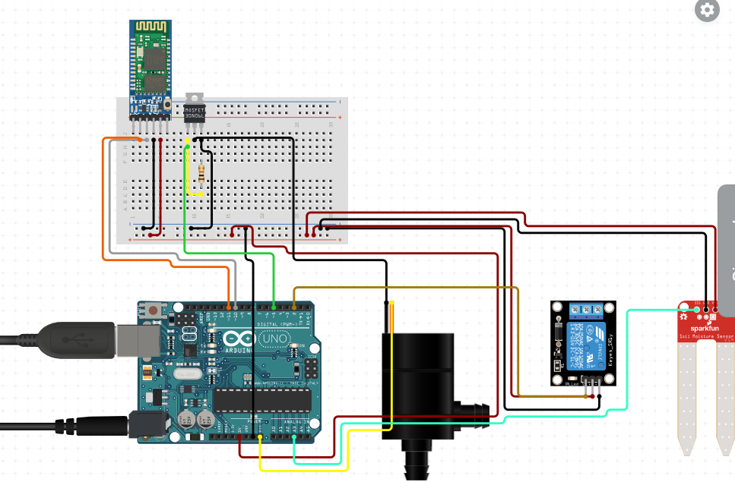

# Steps of Circuit Completion:-

1. we connected arduino UNO to the soil moisture sensor in analog A0 port.
2. Then comes the relay module part where the module is connected to its familiar ports to recieve power.
3. The submersible pump is further being connected to the arduino and using 220V power adaptor supply.
4. Atlast the bluetooth is being connected to receive the data from the sensor.

# Program Code

*https://github.com/debashisgarai18/auto_irrigation_system*